**DBT MODULE END EXAM**

**Email**: [saurabh.mahajan.cmaug25@gmail.com](mailto:saurabh.mahajan.cmaug25@gmail.com)

**PRN:** 250840320179

**Name:** Saurabh Anil Mahajan

**Section A-**

**DBT Query:**

1. create table suppliers(supplierID int primary key auto_increment, suppliername varchar(50) not null, contactemail varchar(15) not null unique);

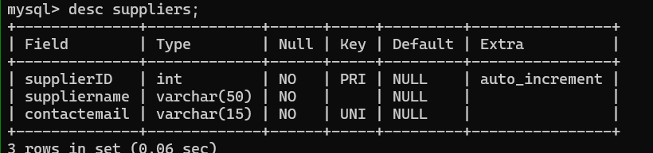

create table flower(flowerID int primary key auto_increment, flowername varchar(100) not null, flowertype varchar(50) not null, priceperstem decimal(8,2) not null, supplierID int, foreign key (supplierID) references suppliers(supplierID));

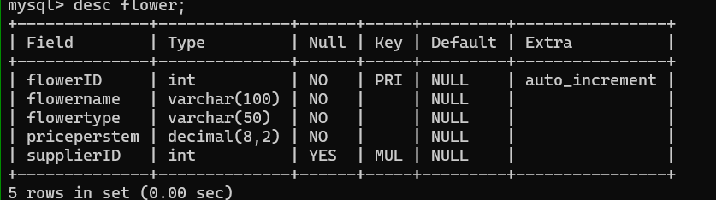

create table customers(customerID int primary key auto_increment, firstname varchar(50) not null, lastname varchar(50) not null, contactnumber varchar(15) not null unique);

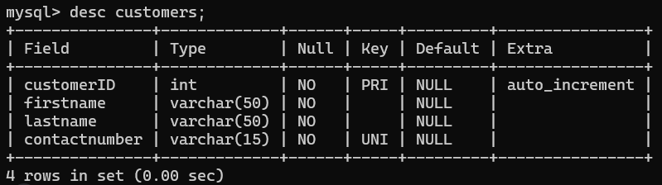

insert into suppliers(suppliername, contactemail) values ('rakesh', 'rakesh@gmail'),('prashant','prashnat@hmail'),('ganesh', 'ganesh@gmail'),('santosh', 'santosh@gamil'),('pravin', 'pravin@gmail');

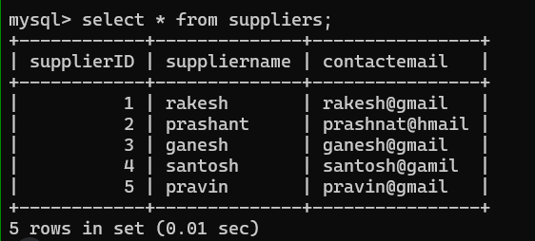

insert into flower(flowername,flowertype,priceperstem,supplierID) values ('pink rose', 'rose', 150, 5),('water lily', 'lily', 250, 4),('red rose','rose', 100,5),('yellow tulip','tulip',300,2),('purple lily','lily',200,1);

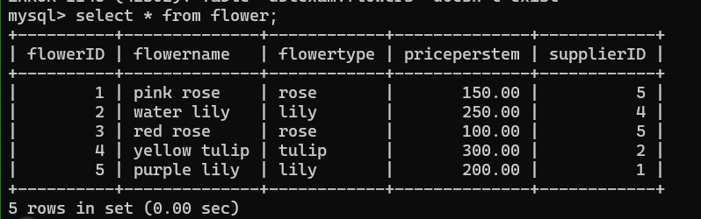

insert into customers values (101, 'saurabh','shah',123456789);

insert into customers(firstname, lastname, contactnumber) values ('riya','sharama',987654321),('manu','singh',321654987),('rohit','gill',123789456),('shubham','more',987123654);

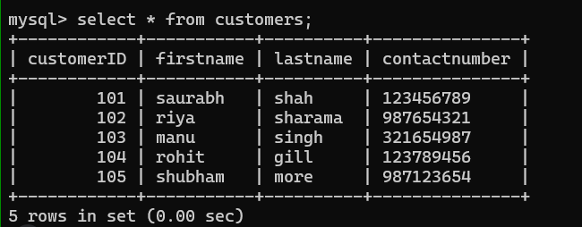

1. alter table flowers add constraints fk_suppliers foreign key (supplierID) references suppliers(suppliersID);



1. select * from flower where flowertype = 'rose' or priceperstem > 100;

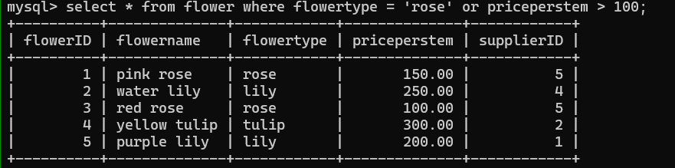

1. select * from flower limit 5;

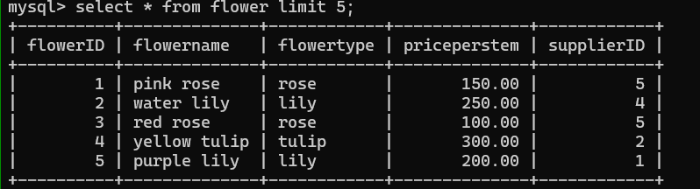

**SECTION B**

1. select flowername, priceperstem from flower where priceperstem = (select max(priceperstem) from flower);

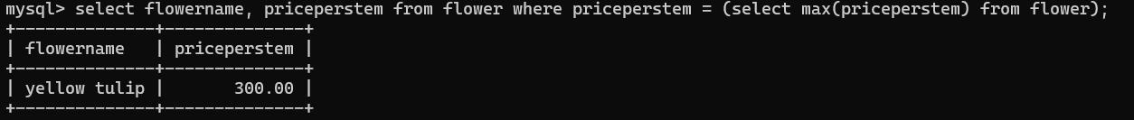

1. create view flowersummary as select flowername, flowertype , priceperstem from flower;

update flowersummary set priceperstem = 120 where flowername = 'red rose';

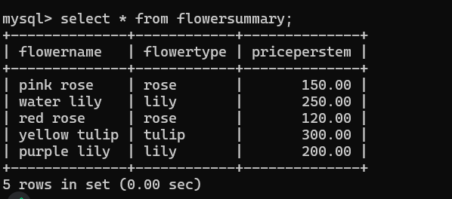

1. select f.flowername, f.flowertype, s.suppliername

from flower f

left join suppliers s

on f.flowerID = s.supplierID;

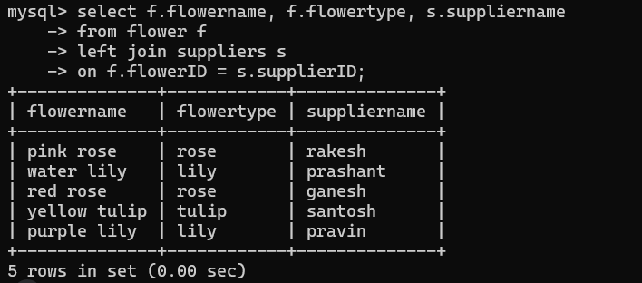

1. create temporary table tulipflower as select * from flower where flowertype = 'tulip';

select * from tulipflower;

drop temporary table tulipflower;

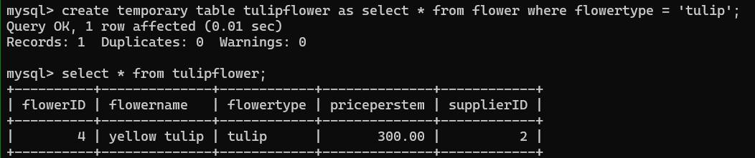

1. DELIMITER //

create procedure getflowerdetails(IN flowersID int)

BEGIN

Select flowername , priceperstem from flower where flowerID = flowersID;

END//

DELIMITER;

**SECTION C**

14. select flowername, priceperstem from flower where priceperstem = (select max(priceperstem) from flower where priceperstem < (select max(priceperstem) from flower));

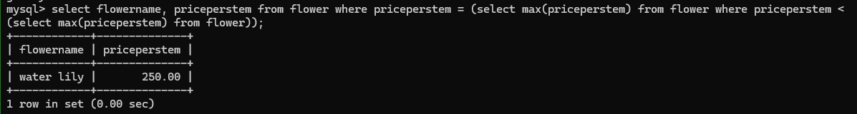

12. select s.supplierID , s.suupliername, COUNT(DISTINCT f.flowertype) AS typessupplied from suppliers s JOIN flower f ON s.supplierID = f.supplierID